c

Online Test System

User Manual

Group 5

Contents

1. Introduction 3

2. Admin Manual 4

2.1 Edit Profile 4

2.2 Manage Users 4

2.2.1 Check Existing Users 5

2.2.2 Add One User 5

2.3 Manage Students 6

2.3.1 Check Existing Students 6

2.3.2 Register New Student 7

2.3.3 Import Students by Excel File 7

2.4 Manage Categories 8

2.4.1 Check Existing Categories 8

2.4.2 Add Categories 9

2.4.3 Check Existing Sub Categories 9

2.4.4 Add Sub Categories 10

2.5 Manage Questions 11

2.5.1 Check Existing Questions 11

2.5.2 Add a Question 11

2.5.3 Import Questions by Excel file 12

2.6 Check Out Assignments 13

2.6.1 Check out All the Students who are generated the Test 14

2.7 Check Test Results 15

3. DBA Manual 17

3.1 Edit Profile 17

3.2 Manage Questions 18

3.2.1 Check the existing question 18

3.2.2 Add a New Question 18

3.2.3 Import Questions by Excel File 19

4. Coach Manual 20

4.1 Edit Profile 20

4.2 Manage Students 21

4.2.1 Check Existing Students 22

4.2.2 Register a New Student 22

4.1.3 Import Students by Excel File 23

4.3 Manage Questions 23

4.3.1 Check the existing question 23

4.3.2 Add a Question 24

4.3.3 Import Questions by Excel file 24

4.4 Generate Assignment to Student 25

4.5 Check Out Assignments 27

4.5.1 Check out If a Student Take the test 27

4.5.2 Check out All the Students who are generated the Test 28

4.6 Check Test Results 29

5. Student Manual 30

5.1 Take the Test 30

6. Revision History 33

# Introduction

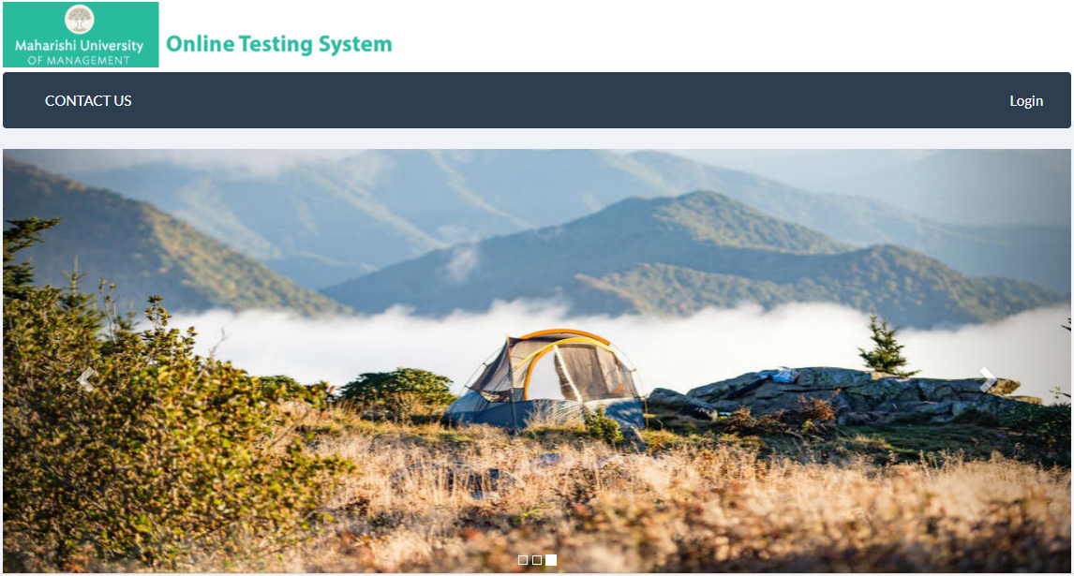

This document is the User Manual of the MUM Online Test System. MUM Online Test System is used for job-seeking students to help review the interview questions (for example, Java and JavaScript).

There are 4 types of roles in the system: Admin, DBA, Coach and Student. You could find who you are in the right corner of the window.

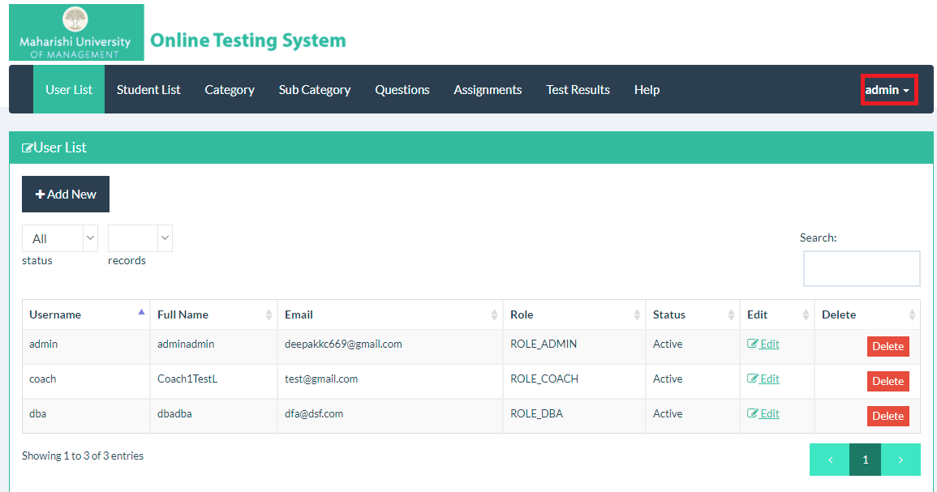

Admin, DBA and Coach are the administrators of the system, which are usually handled by university staff. Student means the MUM students who are doing job seeking, which will take part in the test once they receive the test link from email triggered by university staff from whom that holds the Coach Account.

# Admin Manual

Admin user is the super user of the system. Please check the function of the Admin User below:

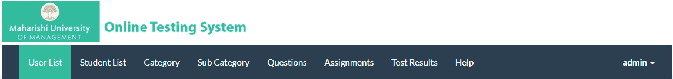

## Edit Profile

As an admin you are able to edit your own profile including changing your password.

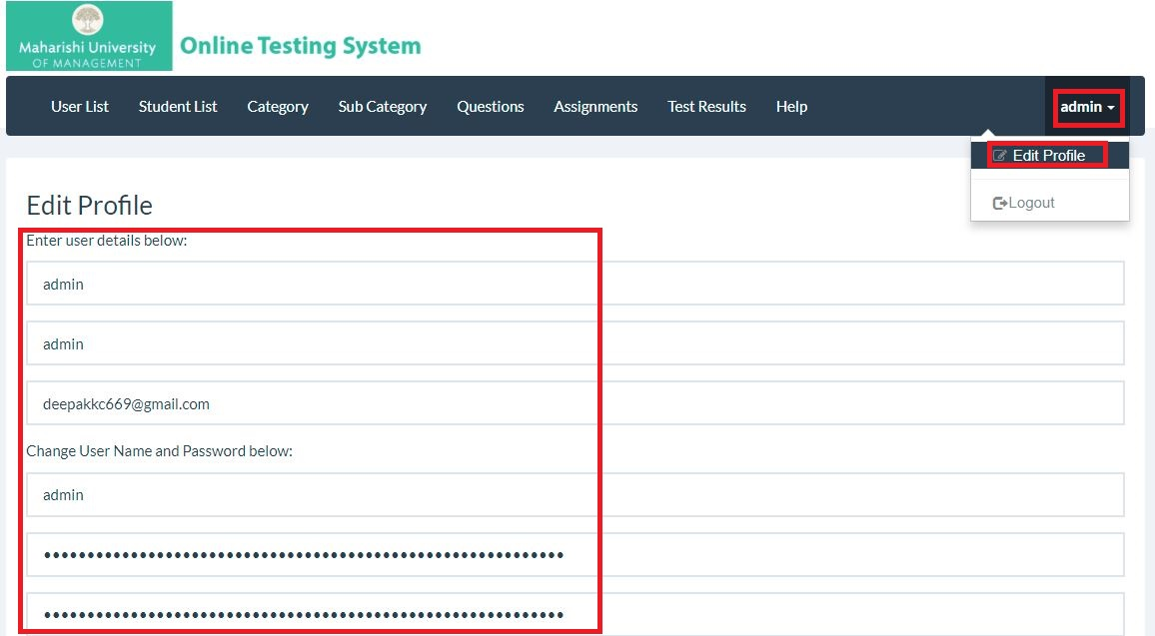

## Manage Users

Admin user could manage all the other 3 types of users (Coach, DBA and Student).

### 2.2.1 Check Existing Users

You could check the users that are already stored in the system. Reminder: Users here concludes all Admin, Coach and DBA users.

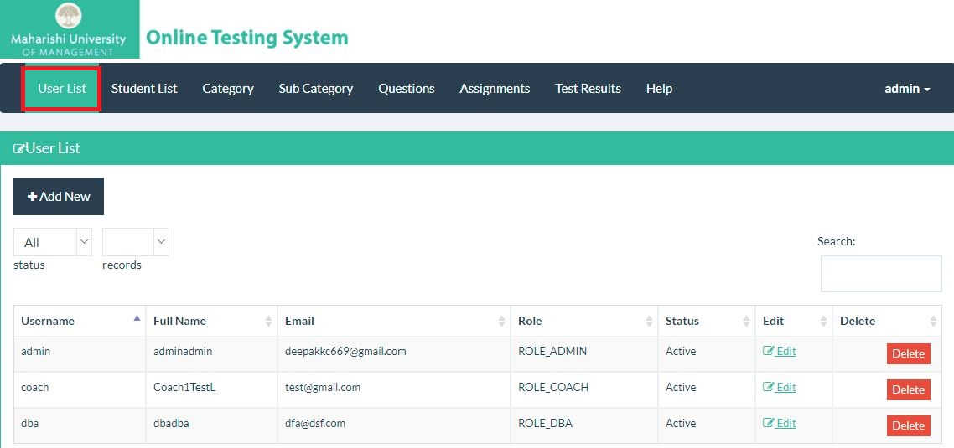

### 2.2.2 Add One User

By clicking the Add New button, you are able to add a new user and assign him the role of Admin, Coach or DBA.

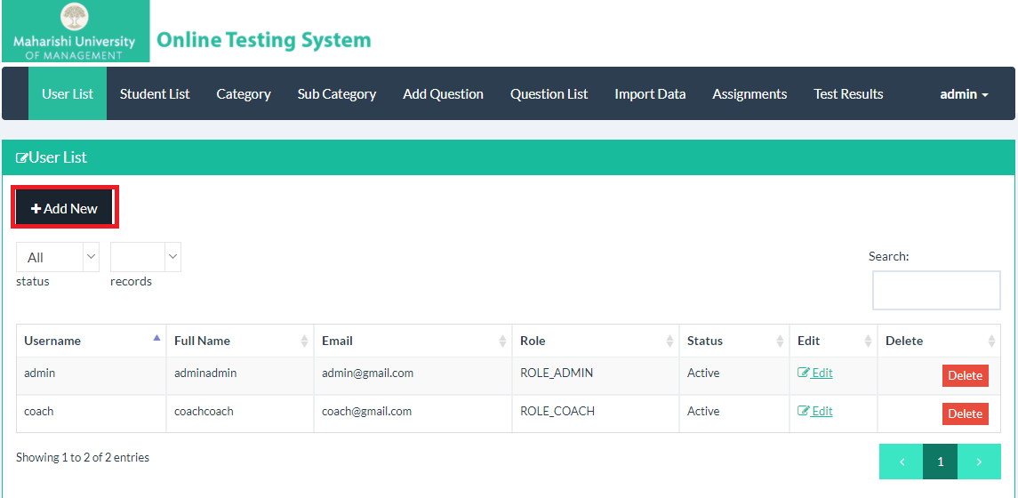

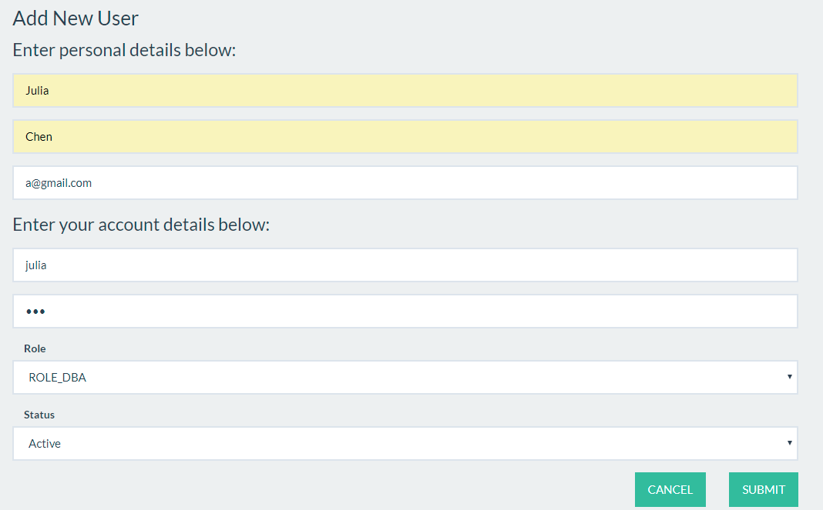

## Manage Students

Students here mean MUM students who are doing job seeking and taking tests on this system after Coach generates the test.

### Check Existing Students

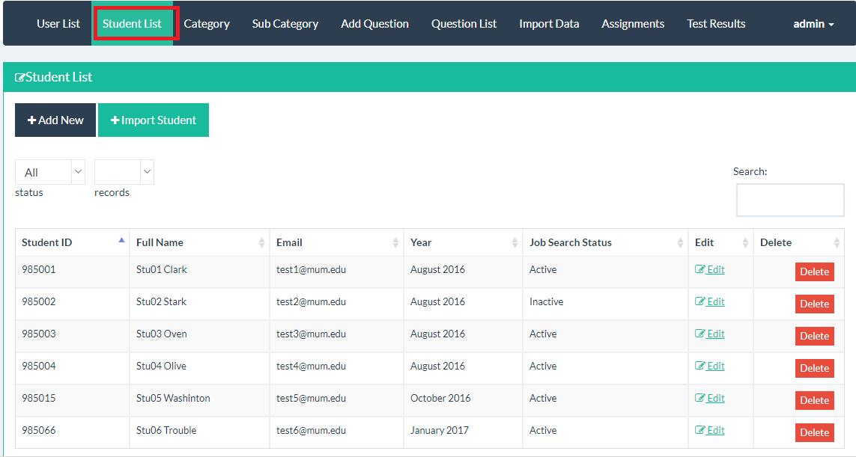

### Register New Student

Click the Add New Button under Student List Menu

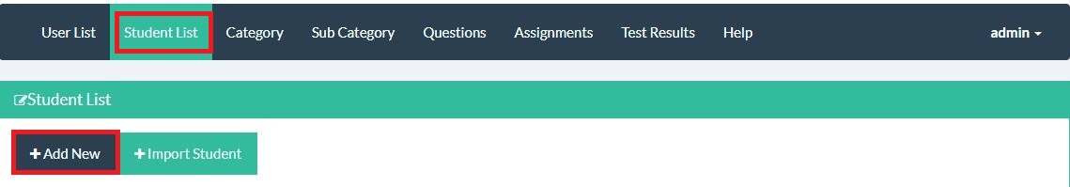

Input the student information

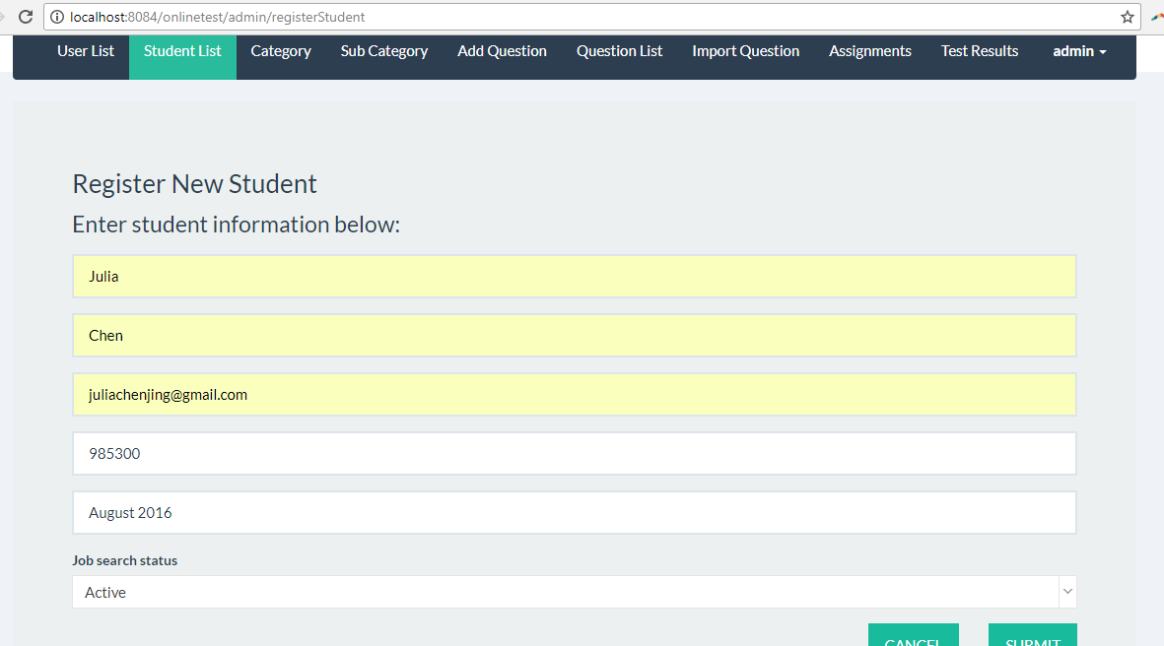

Click Submit Button, system will save the added Student.

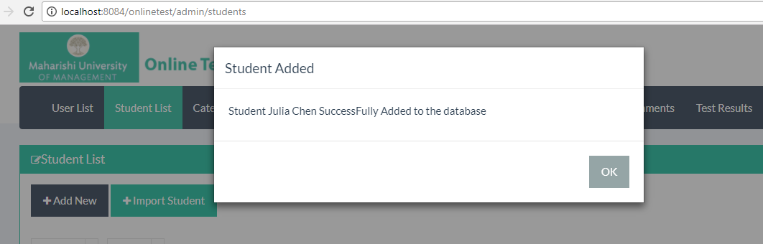

### Import Students by Excel File

You could import a big amount of students by using Import Student Button.

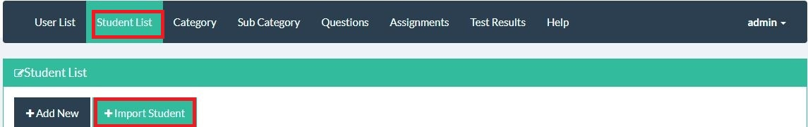

Click the Choose File button.

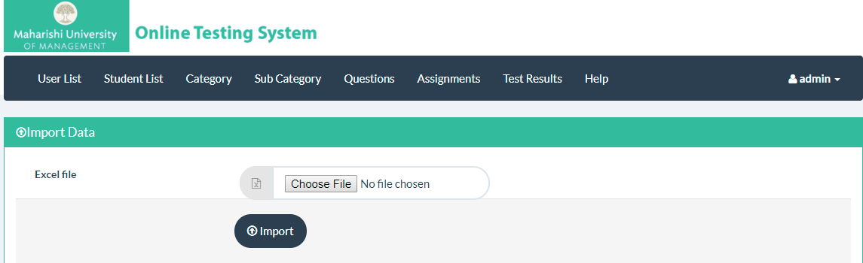

Get ready for the file with the format shown below:

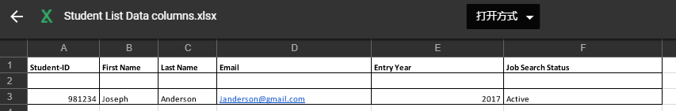

## Manage Categories

Every question belongs to a Sub Category, and each Sub Category belongs to a Category.

### 2.4.1 Check Existing Categories

You could check the existing categories

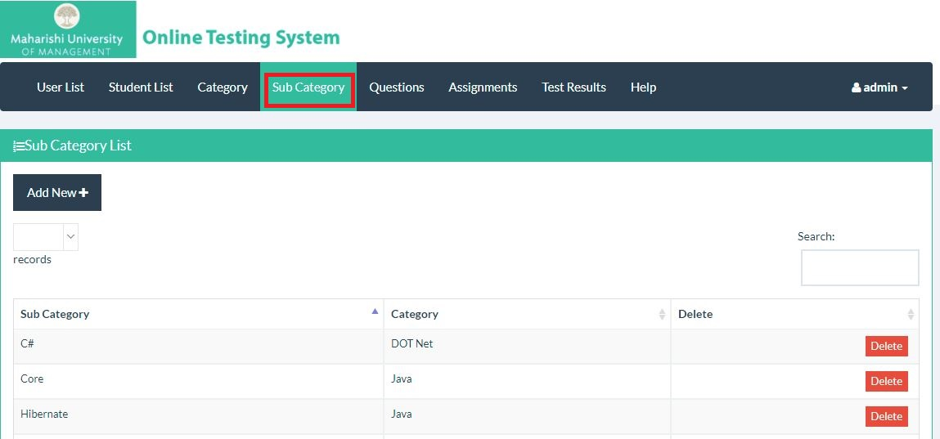

### 2.4.2 Add New Category

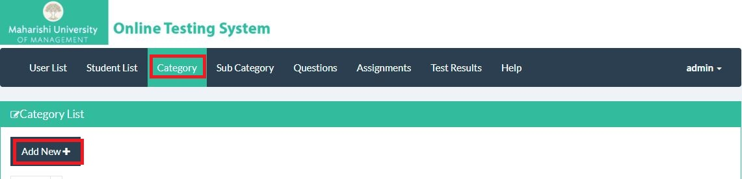

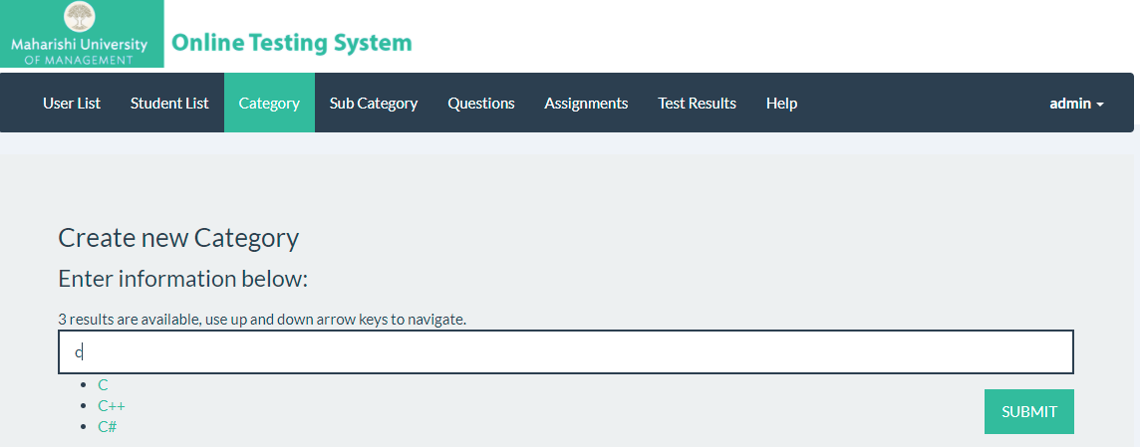

### 2.4.3 Check Existing Sub Categories

Each Sub Category belongs to one Category.

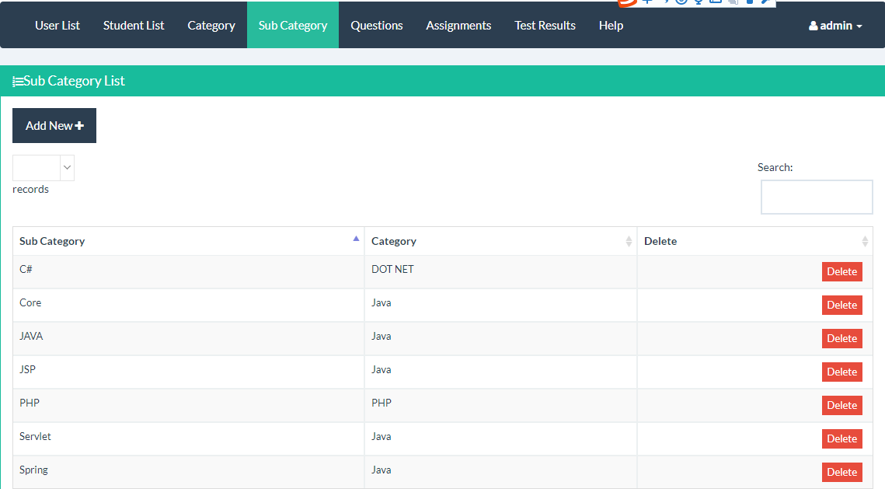

### 2.4.4 Add New Sub Category

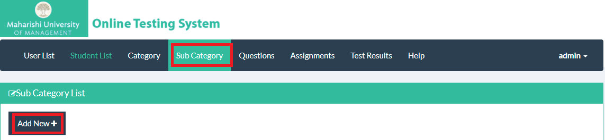

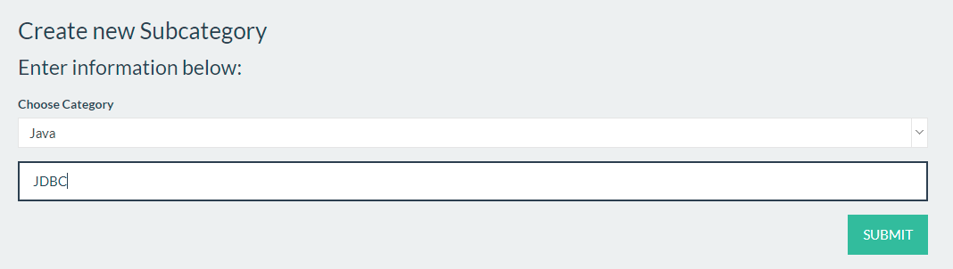

## Manage Questions

### 2.5.1 Check Existing Questions

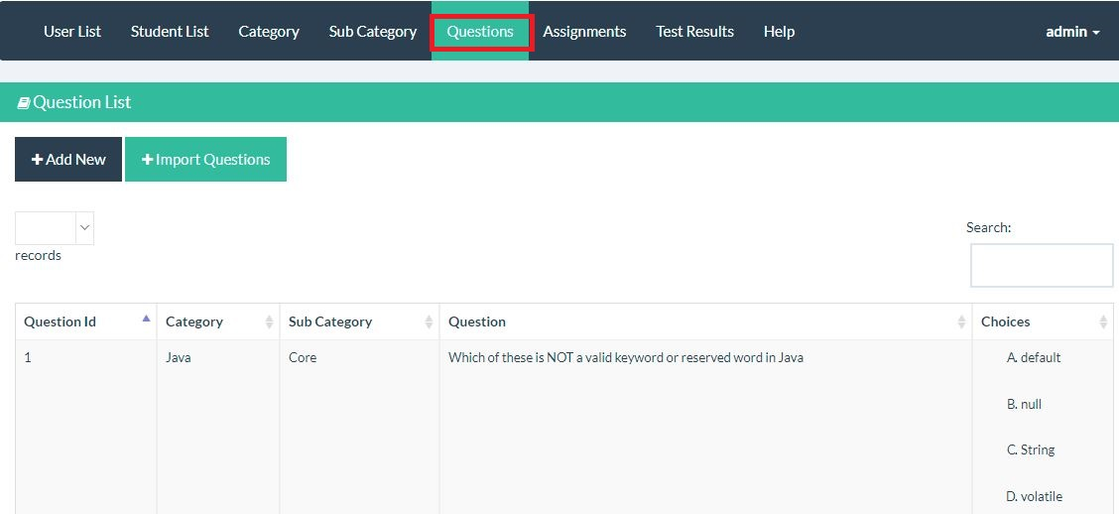

### 2.5.2 Add a Question

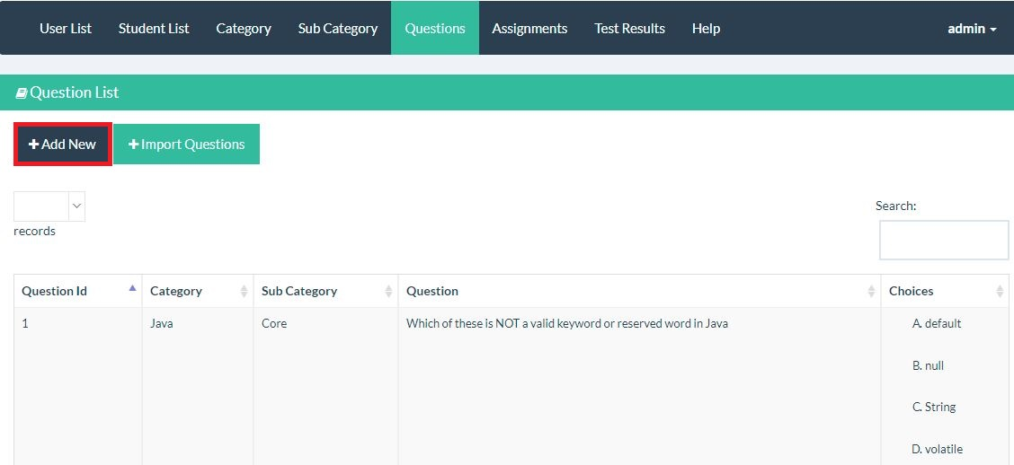

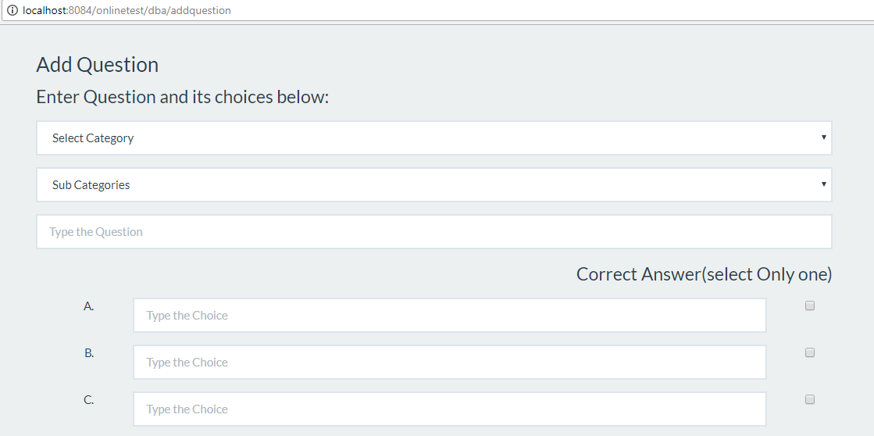

### 2.5.3 Import Questions by Excel file

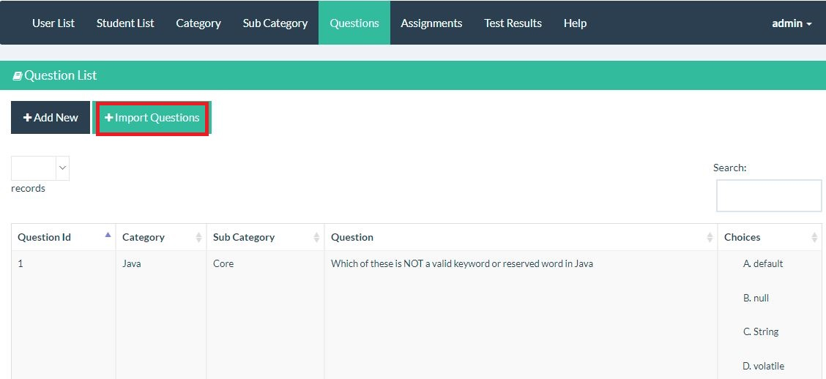

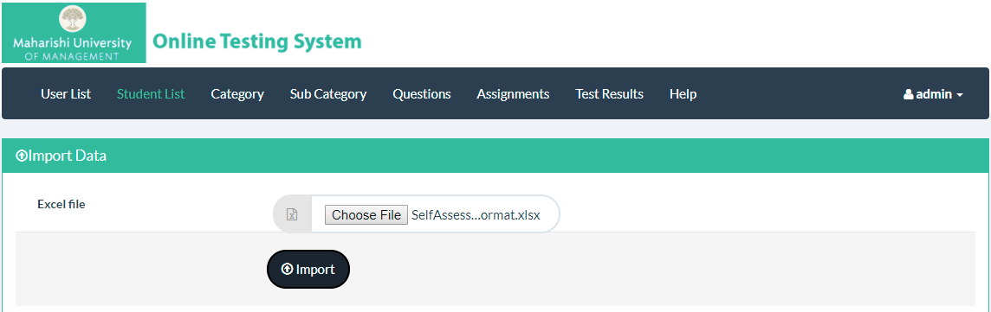

Please follow the format below:

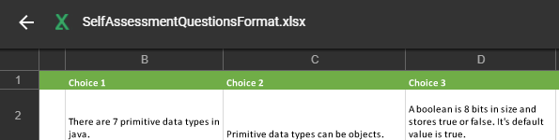

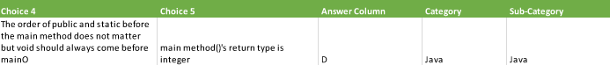

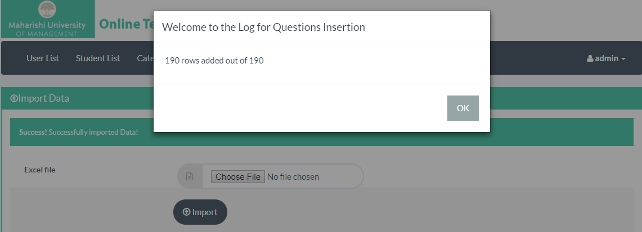

## Check Out Assignments

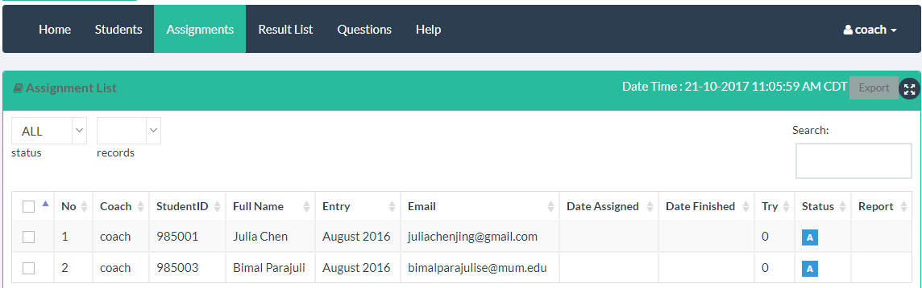

### Check out All the Students who are generated the Test

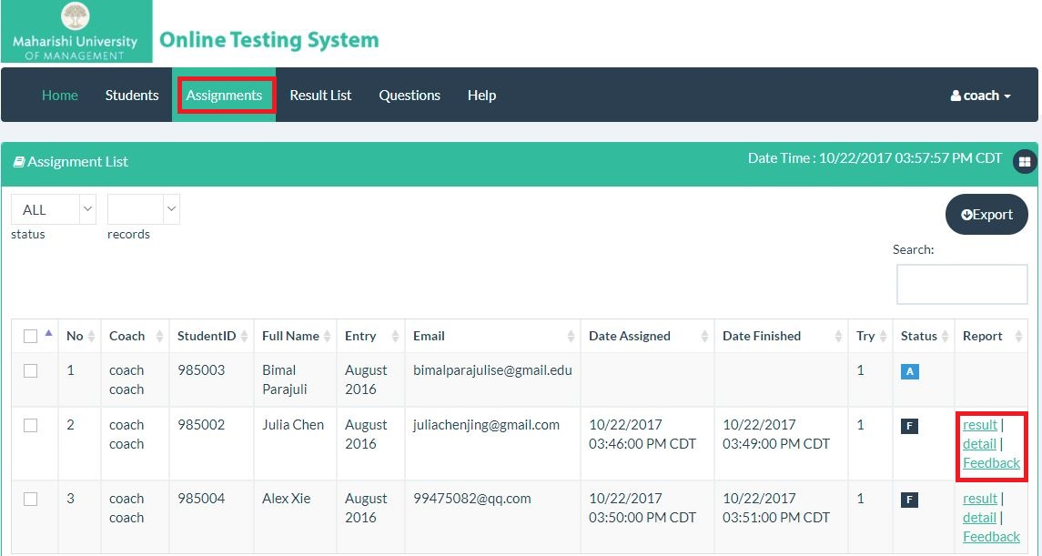

You could click the Result button to check the report shown below.

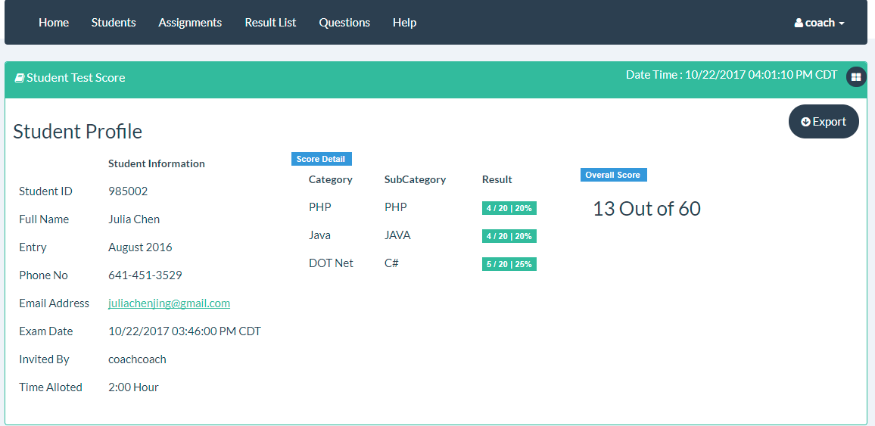

Or click the Detail button to check student’s answer detail.

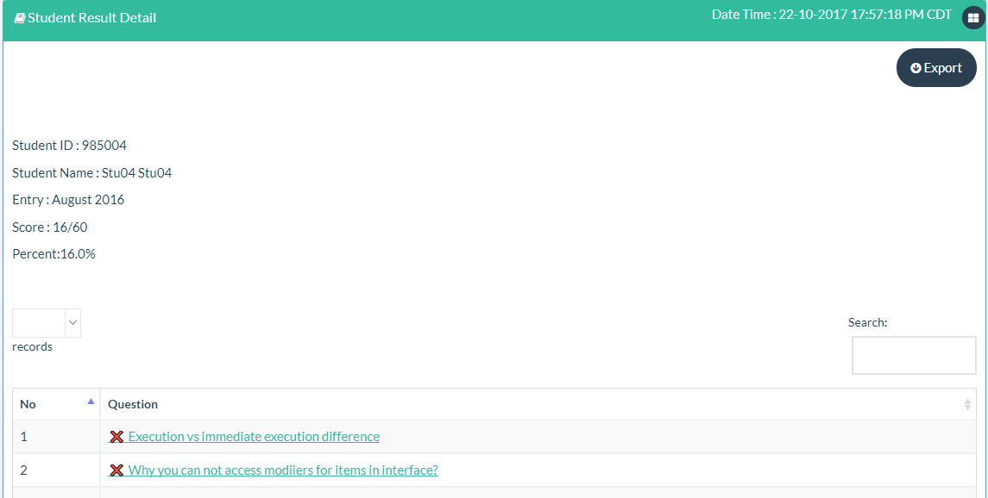

All reports could be downloaded by clicking Export button.

You could also click the Export Button to download the report as excel format.

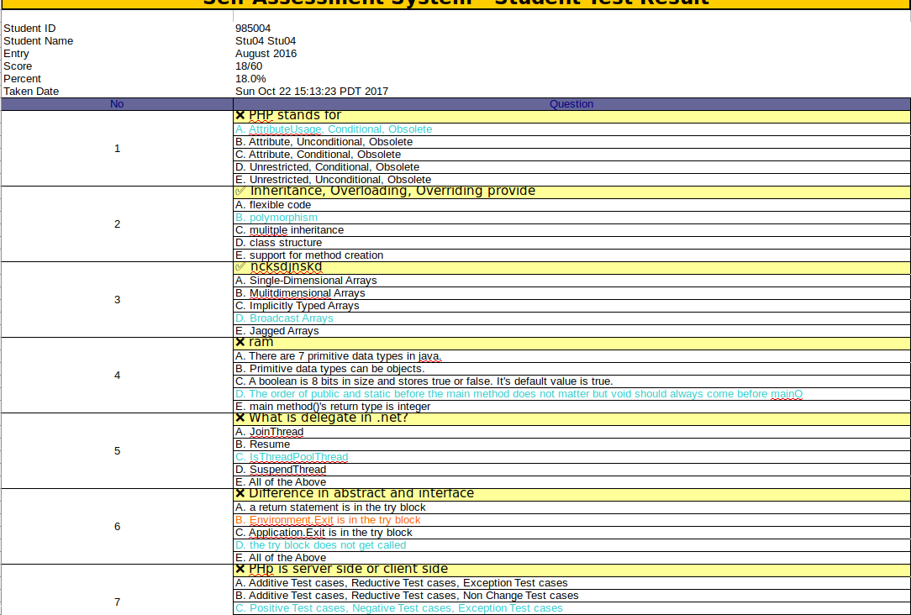

## Check Test Results

Click the Result List button, you could check all the results of the test. You could also click the Export Button to download the report.

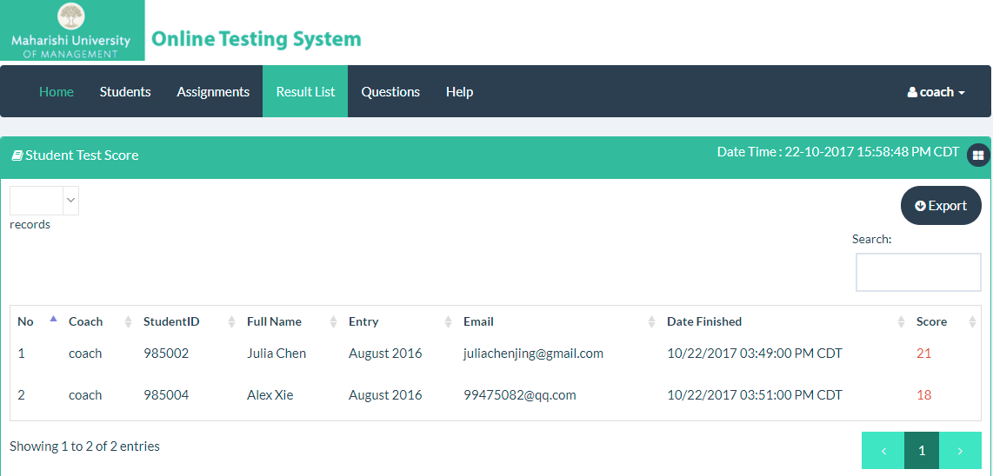

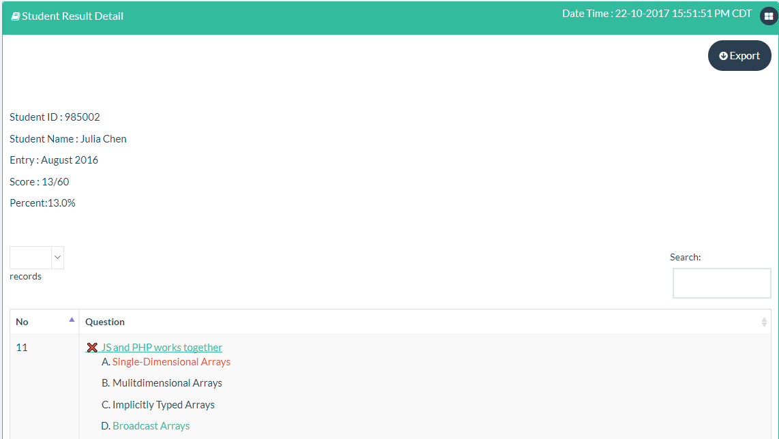

You could also click the Export Button to download the report as excel format.



# DBA Manual

## Edit Profile

As a DBA you are able to edit your own profile including change your password.

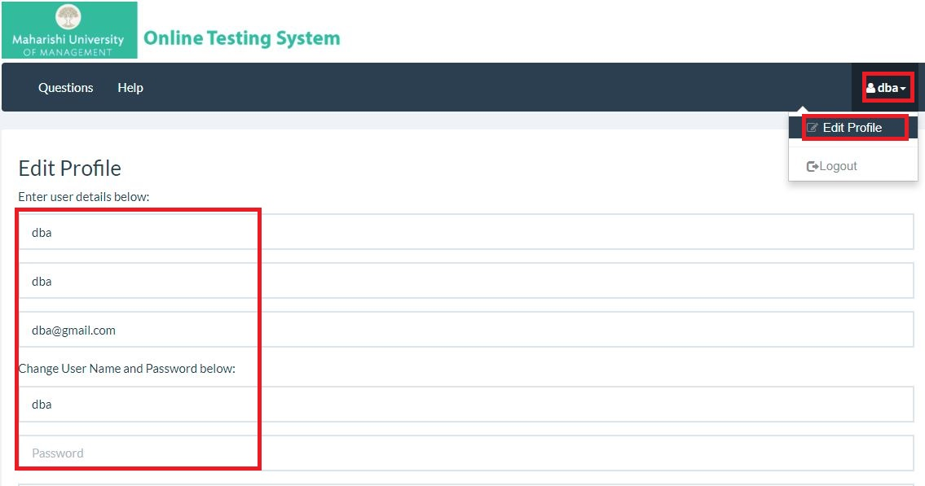

## Manage Questions

### 3.2.1 Check the existing question

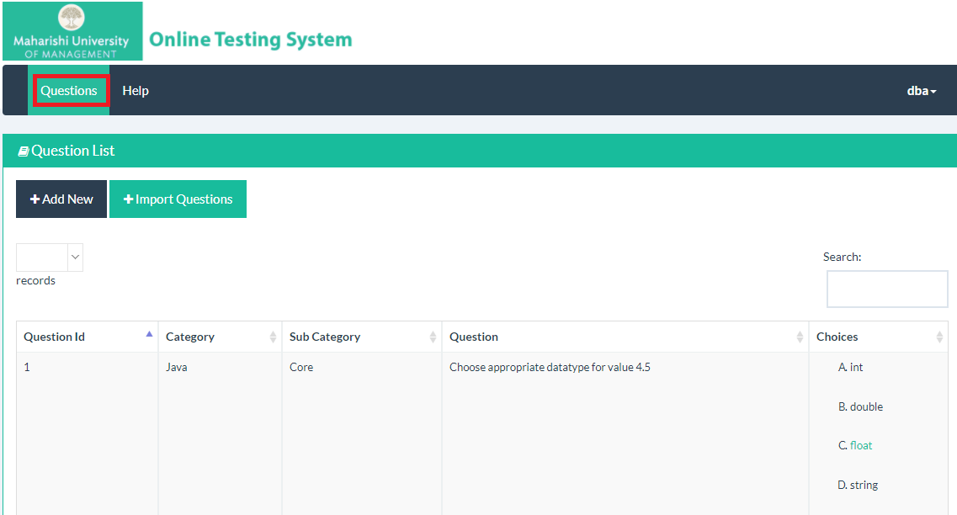

### 3.2.2 Add a New Question

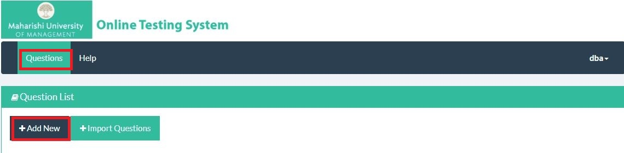



### 3.2.3 Import Questions by Excel File

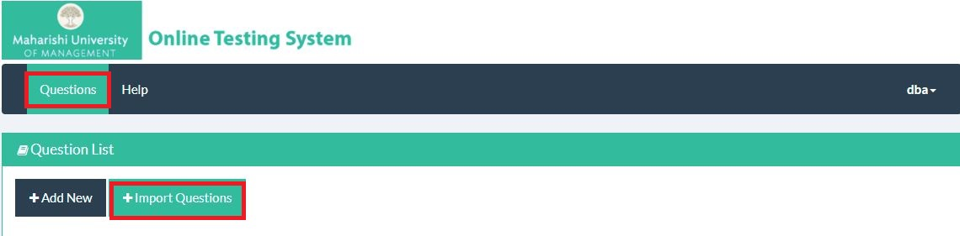

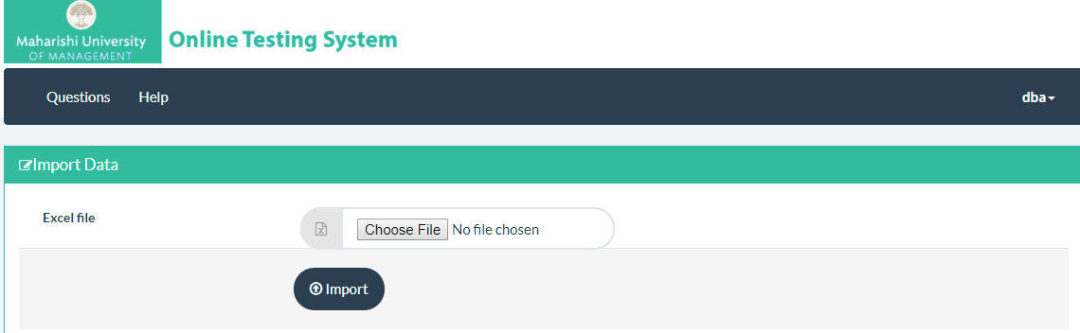

Please follow the format below:







# Coach Manual

Coach is responsible for generating the test for Students. Coach could also manage Student List, Question List and check test results.

## Edit Profile

As a Coach you are able to edit your own profile including change your password.

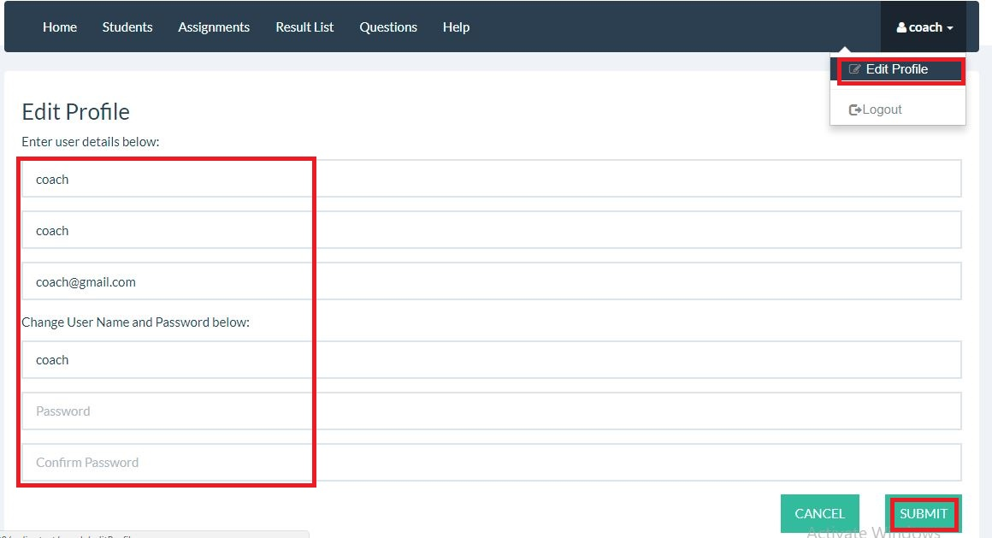

## Manage Students

Students here mean MUM students who are doing job seeking.

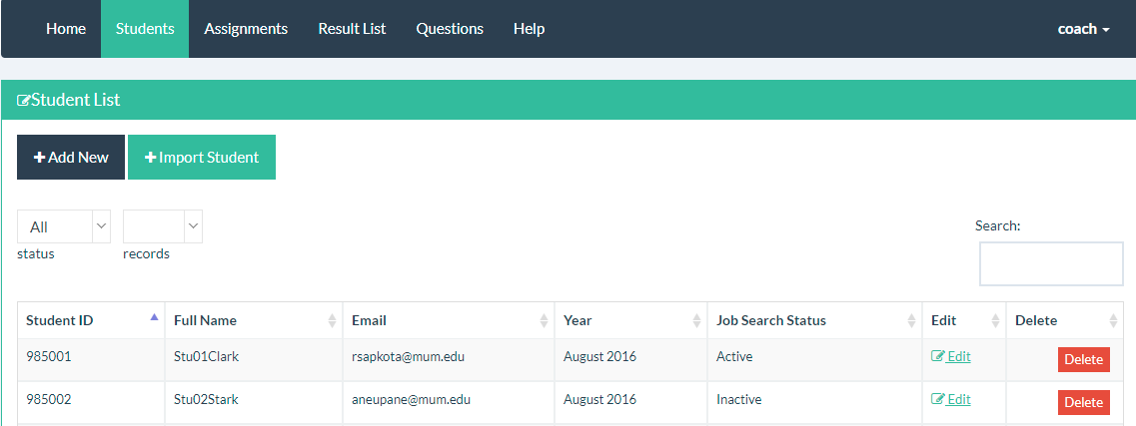

### Check Existing Students

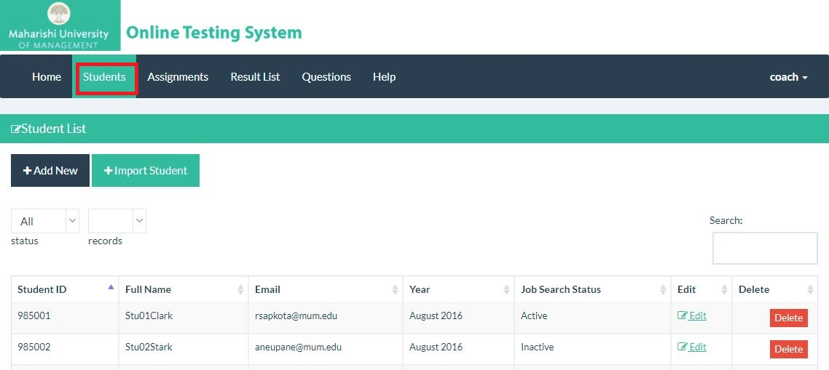

### Register a New Student

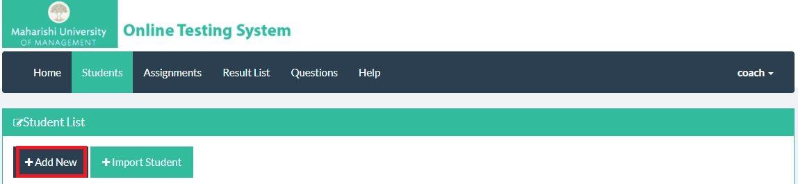

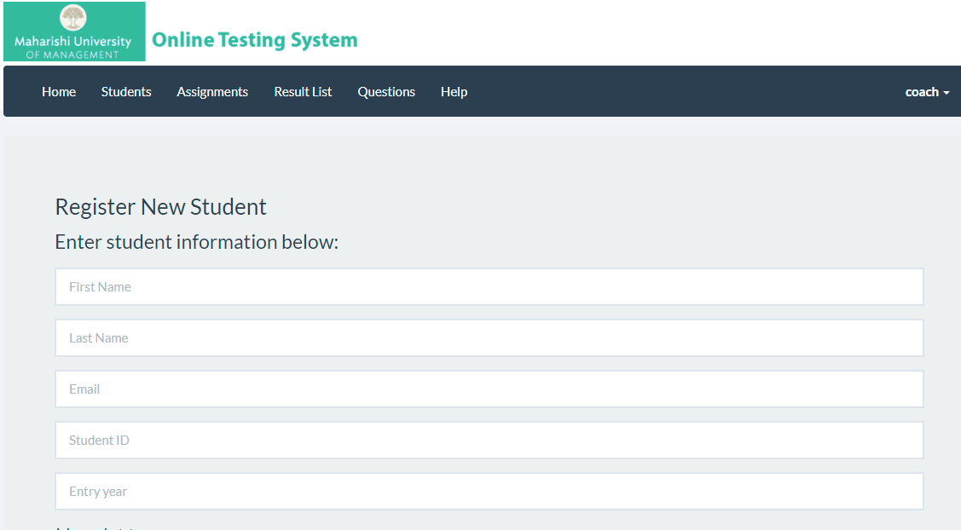



### 4.1.3 Import Students by Excel File

You could import a big amount of students by using Import Student Button.

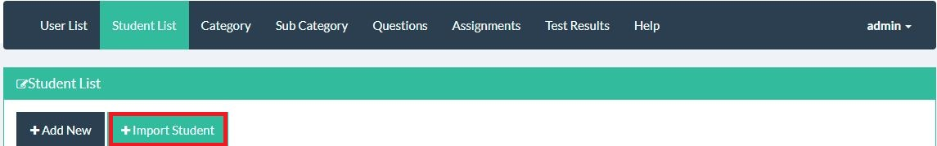

## Manage Questions

### 4.3.1 Check the existing question



### 4.3.2 Add a Question





### 4.3.3 Import Questions by Excel file

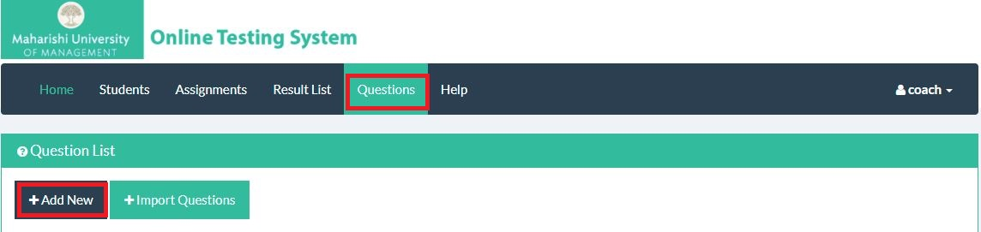

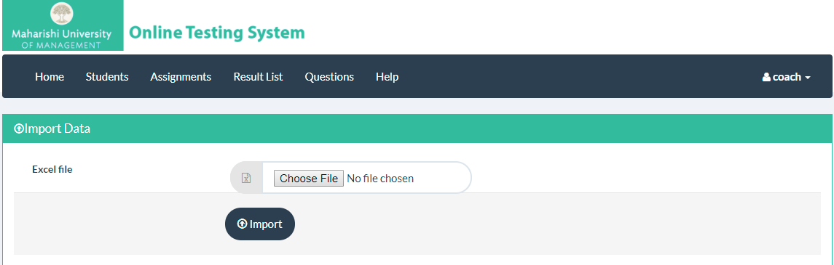

Please follow the format below:







## Generate Assignment to Student

Coach could choose a student and generate an assignment (a quiz test) to a certain student. The test link could be set to a certain time to send.

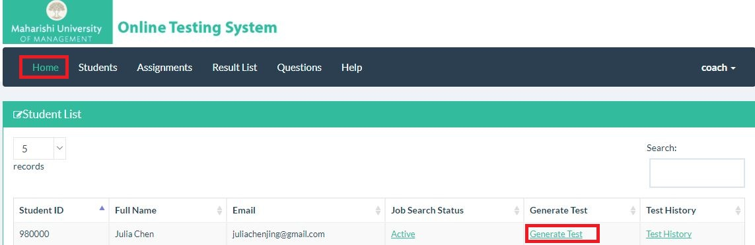

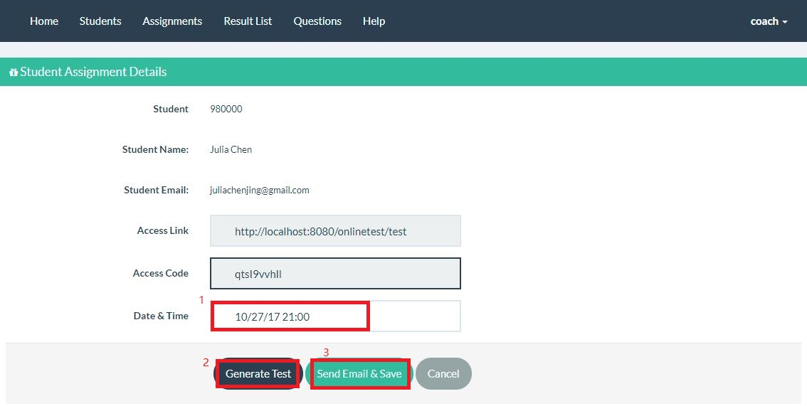

Then the email will be sent to the certain student at the chosen time.

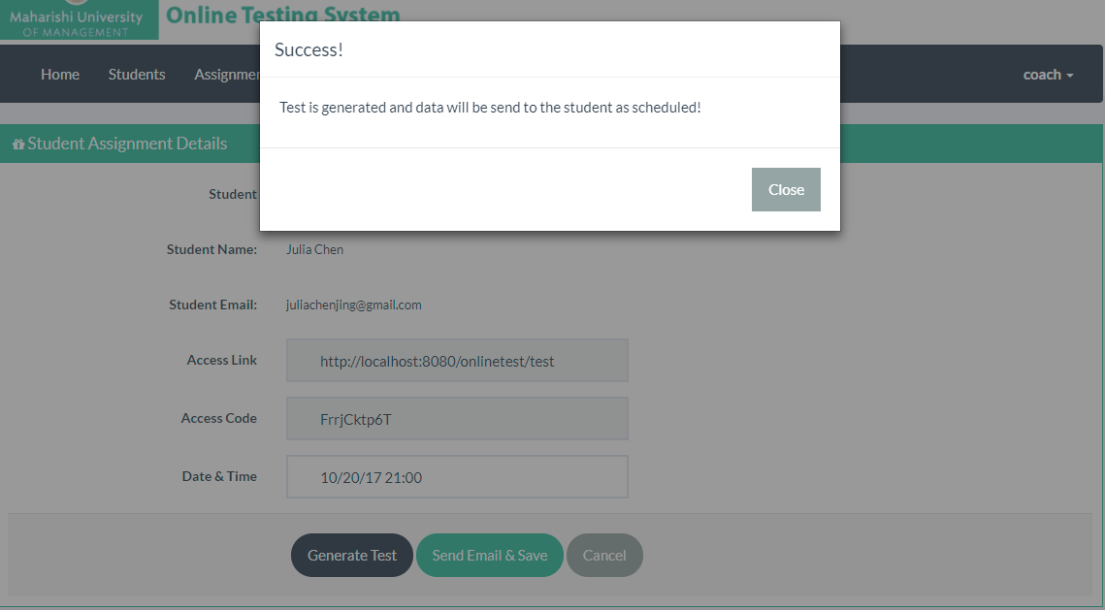

## Check Out Assignments



### Check out If a Student Take the test

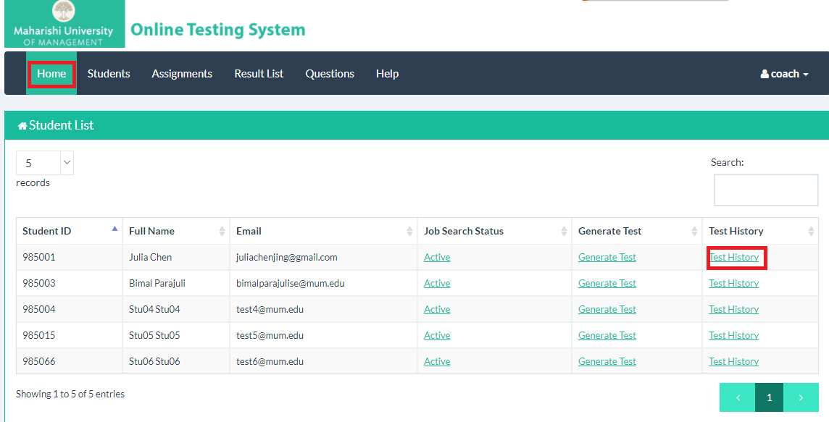

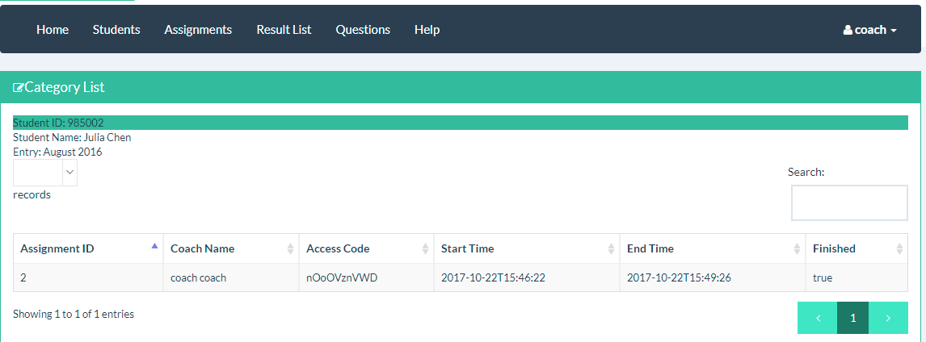

### Check out All the Students who are generated the Test



You could click the Result button to check the detailed student result.



You could click the Detail button to check the detailed student answer.



You could also click the Export Button to download the report as excel format.



## Check Test Results

Click the Result List button, you could check all the results of the test. You could also click the Export Button to download the report.



# Student Manual

## Take the Test

As a student who is doing job seeking, every now and then Coach will generate some online test to help you find the weak point of your knowledge tree. All you need is to follow the guide below:

After the coach generates the test, you will receive the link and Access Code in your email:

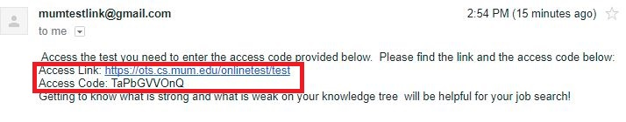

Click the link, and you will see the guidance:

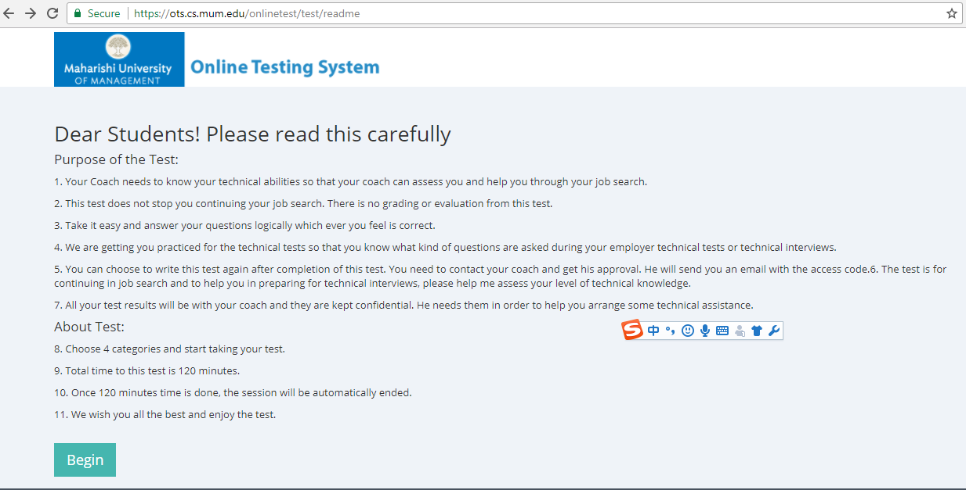

Input the Access Code shown in mail:

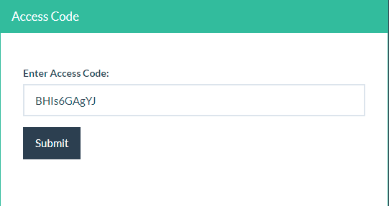 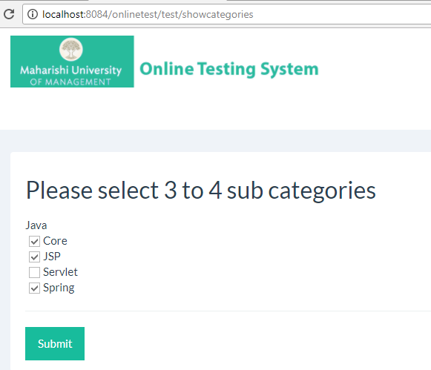

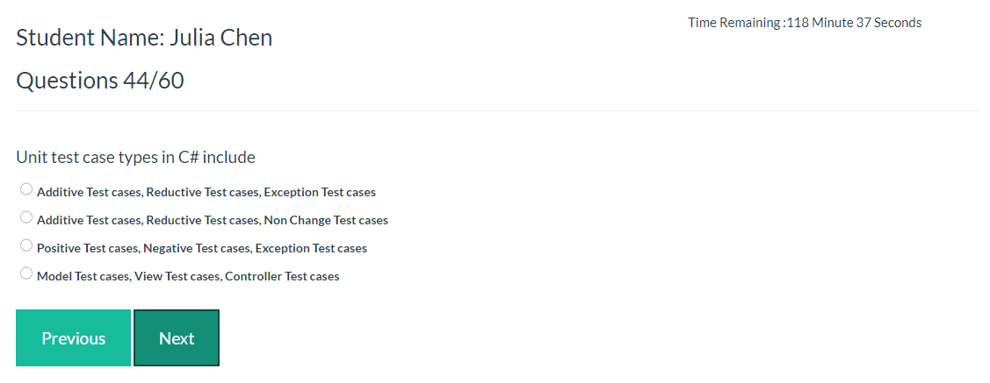Please double check before you submit your answers to grade: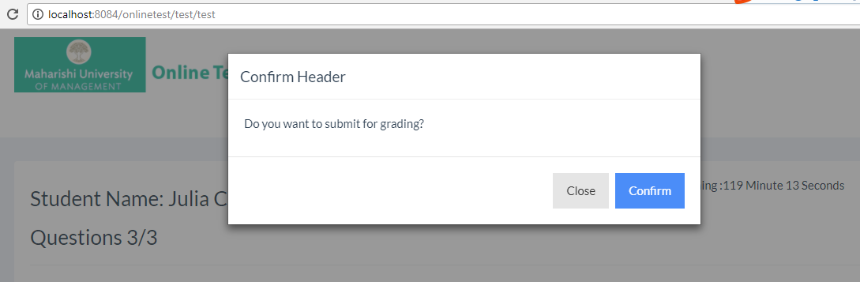 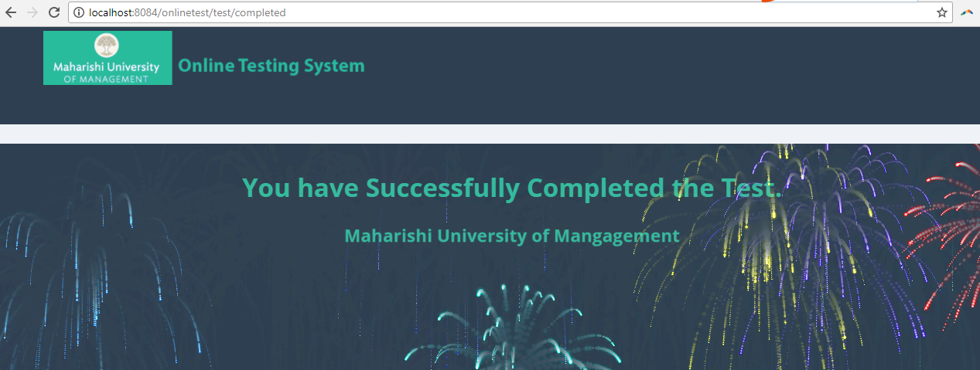

# Revision History

|  |  |  |  |  |
| --- | --- | --- | --- | --- |
| Version | Date | Author | Description | Approver |
| V1.0 | 10/22/2017 | Julia | First Version |  |
|  |  |  |  |  |